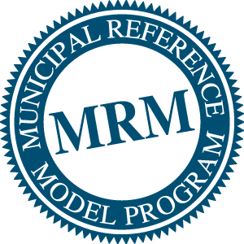 | MRM Version 2  Steering Committee Meeting  Agenda: April 29, 2011

Project Name | Municipal Reference Model, Version 2
Project Number | Prepared By | Date
 | Roy Wiseman | April 29, 2011
Meeting Information
Location | Date (YYYY/MM/DD) |  |  |  | Time (from - to)
Region of Peel Headquarters  Mississauga Room, 1st Floor  10 Peel Centre Drive, Suite A  Brampton, Ontario L6T 4B9  If teleconferencing dial:  905-791-5043 or 1-877-560-1022  Conference ID: 17100  Pass code: 427315  Moderator pass code: 258000 | Friday, April 29, 2011 |  |  |  | 2:00pm – 4:00pm (Toronto Time)
Item |  | Who | Time | Required Decisions/Discussion
1. Introductions |  | Roy | 5 minutes
2. Approval of Agenda and Previous Minutes |  | Roy | 5 minutes
3. Project Status (Overview)  - System Architect Peel Pilot  - IBM Business Arrangements  - Standards Board and Model Working Groups  - Business Model Working Group  - Plans for MISA Ontario 2011 and following  - Financial Status  - Intellectual Property  - Project Director |  | Roy | 20 minutes | Discussion and Q&A regarding status
4. System Architect Overview |  | Roy  Skip  Jim | 15 minutes | Findings from pilot to date, Q&A
5. Standards Board and Model Working Groups  - Modeling Principles Working Group  - Reference Model Working Group |  | Skip, Alan, Roy | 15 minutes | Review of work completed to data  - Modeling Principles  - Quick Reference Guide  - Authoritative Reference Model (ARM)  Q&A
- Short Term Business Model |  | JJ | 55 minutes | Confirmation of Short Term Business Plan  Confirmation of Approach to Longer Term Business Plan and Vision  Call out for Volunteer Resources, as requested in Short Term Plan
- Conclusion and Wrap-Up |  | Roy | 5 Minutes

